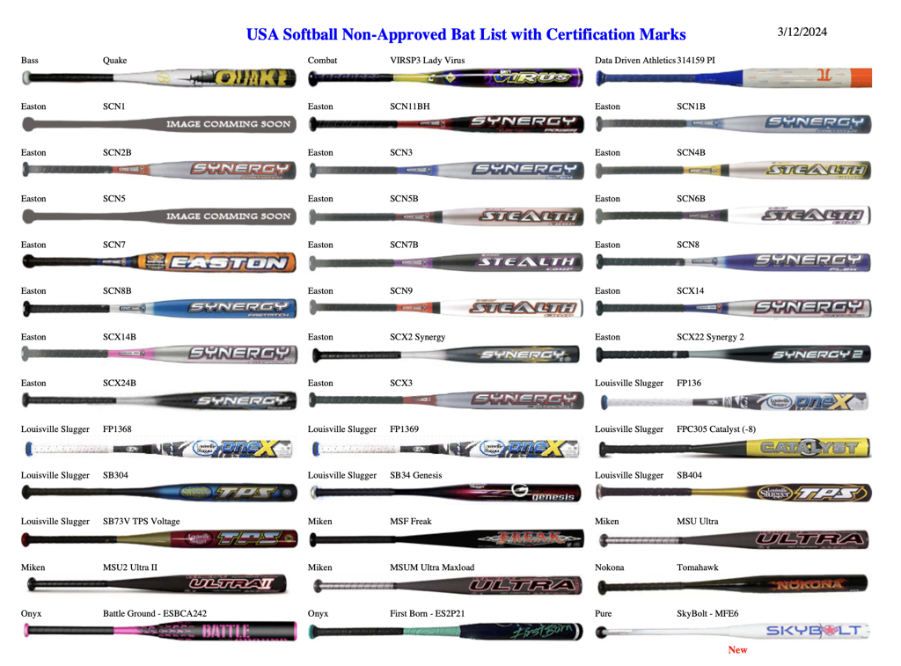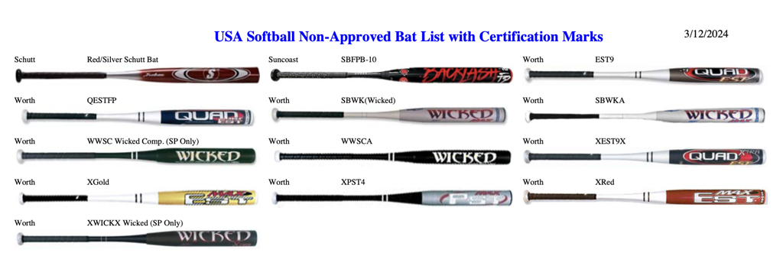

### **USA SOFTBALL BAT TESTING & CERTIFICATION PROGRAM**

**CERTIFIED/APPROVED:** The official bat for USA Softball Championship Play must meet all the USA Softball specifications and the requirements of Rule 3, Section 1, and:

The official bat, made up of the knob, handle, grip, taper, barrel and end cap shall be free of burs, dents cracks, sharp edges, rattles and show no signs of excessive wear. The official bat may be marked OFFICIAL SOFTBALL by the manufacturer, and shall be no more than 34 inches long nor exceed 38 ounces in weight. The official bat shall not be more than 2.250 inches in diameter at its largest part, including any tolerance for expansion. The official bat must bear either the ASA 2000 Certification Mark, ASA 2004 Certification Mark, or ASA 2013 Certification Mark (Slow Pitch, Men’s Adult Fast Pitch, Junior Olympic Boy’s Fast Pitch and Men’s Modified only), as shown below and must not be listed on the ASA Non-Approved Bat List with 2000 or 2004 Certification Mark.

|  |  |  |
| --- | --- | --- |

**AND**

1. must be included on a list of approved bat models published by the ASA  
   OR
2. must, in the sole opinion and discretion of the umpire, have been manufactured prior to 2000 and if tested, would comply with USA Softball Bat Performance Standard. This includes wooden bats