

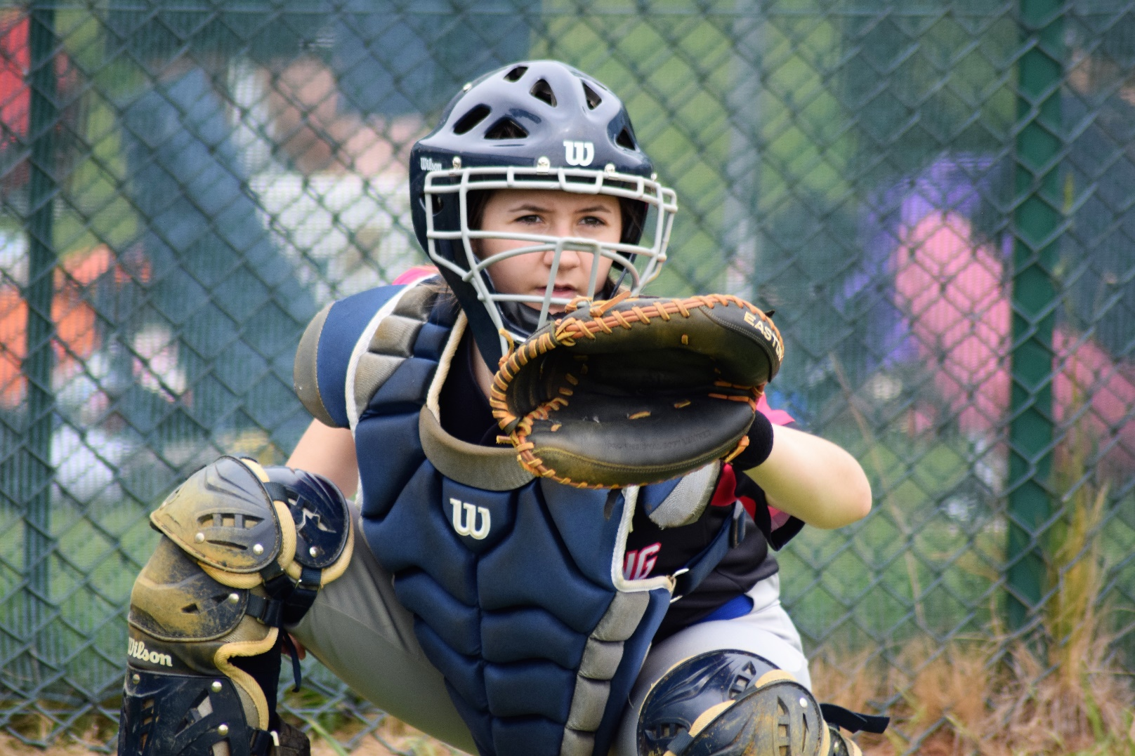

Concussion Policy – Guide and Best Practice

Diversity, Equality and Inclusion

Diversity, Equality and Inclusion (DE&I) ensures fair treatment and opportunity for all. It aims to eradicate prejudice and discrimination on the basis of an individual or group of individuals’ protected characteristics.

BaseballSoftballUK takes seriously its role in recognising and removing any barriers faced by people involved or wanting to be involved in our sports, in any capacity, to ensure the culture of our sports are improved to one that values diversity and enables the full involvement of disadvantaged groups in every aspect of our sports.

Concussions – Guide and Best Practices

What is a concussion?
A concussion is a brain injury typically caused by a blow to the head or body resulting in force being transmitted to the brain. This typically presents as a rapid onset of short-lived brain function impairment that resolves spontaneously.
This impairment results from disruption to the body’s processes rather than a structural injury. And no abnormality is seen on standard hospital scans. A range of signs and symptoms are typically seen, affecting the player’s thinking, memory, mood, behaviour, level of consciousness, and various physical effects. Clear loss of consciousness occurs in less than 10% of cases.
A more detailed definition can be found in the fourth Concussion in Sport Consensus Paper, last updated in 2017, here.

Concussions in baseball and softball
The Joint Baseball & Softball Concussion Working Group recognises that concussion is an important player welfare issue in baseball and softball, and takes its responsibilities very seriously. The Joint Baseball & Softball Concussion Working Group has devised a comprehensive risk management strategy which covers the key priorities of
- Education & Awareness
- Prevention & Mitigation
- Management
- Research
- Communication
The strategy is managed and reviewed by the Joint Baseball & Softball Concussion Working Group on behalf of BaseballSoftballUK, the British Baseball Federation, and the British Softball Federation, and is supported by an independent concussion expert panel. This panel provides advice on concussion policy and monitors emerging research.

Concussions in Baseball & Softball
Concussions occur in everyday life and not just in sport. Baseball & Softball are considered high-speed sports; With likely body impacts between players as well as a hard, thrown ball, there is a risk of accidental head impacts and therefore a potential risk of concussion.
While there is limited data on baseball and softball concussions in the United Kingdom, the National Institute of Health in the United States has found that the concussion rate in collegiate softball is 0.29 per 1000 athletic exposures, while the rate for collegiate baseball is 0.09 per 1000 athletic exposures. An athletic exposure is defined as “one athlete participating in one practice or competition during which the athlete was exposed to the possibility of athletic injury.” The rate of concussions in women’s collegiate softball has increased over the course of the study, while the number of concussions per AE have decreased in baseball, with both sports featuring a lower rate of concussion than contact sports like football or rugby. Nevertheless, concussion is a present, persistent concern in all forms of baseball and softball.

Short/Medium Term Consequences
The majority of people make a full recovery from their concussion within a few days or weeks; however, a small minority of individuals may have persistent symptoms. Concussion and persistent symptoms are very complex conditions which are poorly understood. What is becoming apparent from research is that persistent concussion symptoms do not necessarily reflect an on-going physiological injury to the brain, and there are a number of both pre-injury and post-injury psychological and social factors which appear to have an influence.

Persistent symptoms can however have a major impact on quality of life, education and work. It is therefore important that concussions are managed well, that persistent symptoms are recognised early, and that if identified, such individuals are referred for expert management and support.
Long Term Consequences
The proposed link between concussion and rare neurodegenerative conditions such as
Chronic Traumatic Encephalopathy (CTE) is unclear at present. It is thought that the risk is related to repeated concussions in susceptible individuals who have genetic and other individual risk factors.
While any relationship is unclear at present, it is widely agreed that the benefits of exercise still far outweigh the risks. In the 2022 “Physical Activity: applying All Our Health” UK Government Whitepaper, the Chief Medical Officer for the United Kingdom recommends at least 150 minutes of moderate-intensity activity a week, which playing baseball and/or softball can provide.
This potential future risk of neurodegeneration is why it is so important to manage concussion in accordance with best practices. A failure to observe these practices may put a player at higher risk of developing progressive neurodegenerative problems that may lead to problems with memory, other mild cognitive impairments, or CTE in later life.
Second Impact Syndrome
If you continue to play after sustaining a suspected concussion, or if you return to play before full recovery, you could be exposed to further head impacts and put you at increased risk of a more serious brain injury such as a very rare condition often referred to as Second Impact Syndrome.
It is clearly stated in multiple concussion education documents that a head injury can at its most extreme, lead to death. We also make it clear that it can be very difficult in the early stages to differentiate concussions from other serious brain injuries. This is why we promote the “Recognise and Remove”: approach to this injury within the community game.
Education on the prevention of head impacts, good in-game concussion management, and following the return-to-play guidelines are key to preventing such injuries from occurring.

Multiple/Repeated Concussions
As there is considerable variation in the initial effect of concussion that a player can experience, with individuals having different thresholds and responses, spontaneous recovery can be often rapid; this can increase the potential for players to ignore concussion symptoms at the time of injury or return to play before they’ve fully recovered. There are therefore concerns that repeated concussion – particularly before full recovery – could shorten a player’s career, significantly interfere with their athletic performance, and may have some potential to result in permanent neurological impairment.
Players who experience two or more concussions in 12 months or multiple concussions over the course of their career should be reviewed on an individual basis. The severity of the concussion and recovery can affect the approach that is taken; some players may require an extended period out of the game. It may also be appropriate to look at the mechanism of injury/how are these concussions occurring; for example, are concussions occurring during defensive plays, and if so, how can this be addressed by the player/coach.
If a player has repeated concussions, it is recommended that they are seen by a doctor specialising in concussion management (through a doctor referral). Each concussion should be considered on its own but a more conservative timescale for recovery or directed rehabilitation may be recommended especially if each time the force required to cause concession is lessened and/or the symptoms are prolonged.

Other sources of Information:
NHS Choices: https://www.nhs.uk/conditions/head-injury-and-concussion/
Headway: https://www.headway.org.uk/
SHIPS - Supporting Head Injured Pupils in Schools: https://www.shipsproject.org.uk/
Child Brain Injury Trust: https://childbraininjurytrust.org.uk/
Brain and Spine Foundation: https://www.brainandspine.org.uk/
BIRT - Brain Injury Rehabilitation Trust: https://www.thedtgroup.org/brain-injury
HeadInjurySymptoms.Org: https://headinjurysymptoms.org/

The information contained in this document is intended for educational purposes only and is not meant to be a substitute for appropriate medical advice or care. If you believe that you or someone under your care has sustained a concussion, we strongly recommend that you contact a qualified healthcare professional for appropriate diagnosis and treatment. The authors have made responsible efforts to include accurate and timely information. However, they make no representations or warranties regarding the accuracy of the information contained and specifically disclaim any liability in connection with the content in this document

Policy Last Reviewed | Reviewed by | Next Review Due
April 23 | Governance Committee | April 25

